ЛАБОРАТОРНАЯ РАБОТА 6.

ПРИБЛИЖЕНИЕ ФУНКЦИЙ ПО МЕТОДУ НАИМЕНЬШИХ КВАДРАТОВ

Теоретический материал к данной теме содержится в [1, глава 11].
Отчет по лабораторной работе должен содержать следующие материалы по каждой задаче:1) постановка задачи; 2) необходимый теоретический материал; 3) решение поставленной задачи; 4) анализ полученных результатов; 5) графический материал; 6) тексты программ.
Варианты заданий к задачам 6.1-6.3 даны в ПРИЛОЖЕНИИ 6.A.
Фрагмент решения задачи 6.1.0 дан в ПРИЛОЖЕНИИ 6.B.
Задача 6.1. Функция y=f(x) задана таблицей значений 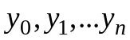 в точках 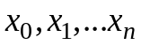. Используя метод наименьших квадратов (МНК), найти многочлен 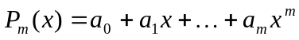наилучшего среднеквадратичного приближения оптимальной степени m=m*. За оптимальное значение m* принять ту степень многочлена, начиная с которой величина 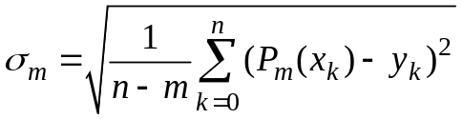стабилизируется или начинает возрастать.
ПОРЯДОК РЕШЕНИЯ ЗАДАЧИ:
1. Задать векторы x и y исходных данных.
2. Используя функцию mnk (см. ПРИЛОЖЕНИЕ 6.В), найти многочлены P_{m}, m=0,1,2,..., по методу наименьших квадратов. Вычислить соответствующие им значения 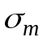.
3. Построить гистограмму зависимости от m, на основании которой выбрать оптимальную степень m* многочлена наилучшего среднеквадратичного приближения.
4. На одном чертеже построить графики многочленов P_{m}, m=0,1,2,..., m*, и точечный график исходной функции.
Задача 6.2. Зависимость между величинами x и y описывается функцией y=f(x, a, b), где a и b – неизвестные параметры. Найти эти параметры, сведя исходную задачу к линейной задаче метода наименьших квадратов.
УКАЗАНИЕ. Свести исходную задачу к линейной задаче МНК можно, сделав подходящую замену переменных. Например, если исходная зависимость имеет вид 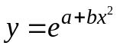, то прологарифмировав исходное равенство и введя новые переменные 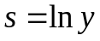и 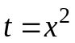, получаем задачу об определении коэффициентов линейной зависимости 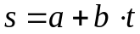.
Задача 6.3. Функция y=y(x) задана таблицей значений 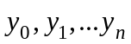 в точках 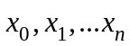. Известно, что зависимость между величинами x и y описывается функцией 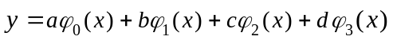, где a, b, c ,d – неизвестные параметры, 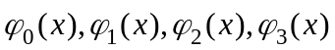 - заданные в индивидуальном варианте функции. Используя метод наименьших квадратов, найти параметры a,b,c,d. На одном чертеже построить графики найденной функции и точечный график исходной функции.
УКАЗАНИЕ. Для нахождения коэффициентов a,b,c,d составить нормальную систему МНК и решить ее способом, указанным в индивидуальном варианте.

ПРИЛОЖЕНИЕ 6.A.

ВАРИАНТЫ ЗАДАНИЙ К ЛАБОРАТОРНОЙ РАБОТЕ 6

Таблица к задаче 6.1
x y  6.1.1 |  |  | x y  6.1.2 |  | x y  6.1.3 |  |  | x y  6.1.4 |  | x y  6.1.5
-1 |  | -2.25 | 0 | 4.568 | -1 |  | 3.614 | -0.5 | 0.72 | -2.1 | 14.1982
-0.7 |  | -0.77 | 0.375 | 3.365 | -0.74 |  | 1.199 | -0.25 | 1.271 | -1.8 | 11.4452
-0.43 |  | 0.21 | 0.563 | 2.810 | -0.48 |  | -0.125 | 0 | 1.2 | -1.5 | 9.1586
-0.14 |  | 0.44 | 0.75 | 2.624 | -0.21 |  | -0.5838 | 0.25 | 0.7363 | -1.2 | 7.2426
-0.14 |  | 0.64 | 1.125 | 0.674 | 0.05 |  | -0.538 | 0.5 | 0.24 | -0.9 | 6.3640
0.43 |  | 0.03 | 1.313 | 0.557 | 0.31 |  | -0.2855 | 0.75 | -0.175 | -0.6 | 4.8182
0.71 |  | -0.22 | 1.5 | 0.384 | 0.58 |  | 0.1111 | 1 | -0.36 | -0.3 | 6.1088
1 |  | -0.84 | 1.690 | -0.566 | 0.84 |  | 0.4529 | 1.25 | -0.328 | 0 | 3.9536
1.29 |  | -1.2 | 1.875 | -1.44 | 1.1 |  | 0.6711 | 1.5 | 0 | 0.3 | 4.6872
1.57 |  | -1.03 | 2.063 | -1.696 | 1.36 |  | 0.6625 | 1.75 | 0.3538 | 0.6 | 4.7601
1.86 |  | -0.37 | 2.25 | -1.91 | 1.63 |  | 0.4501 | 2 | 0.72 | 0.9 | 5.8511
2.14 |  | 0.61 | 2.438 | -2.819 | 1.89 |  | 0.157 | 2.25 | 0.6969 | 1.2 | 7.1010
2.43 |  | 2.67 | 2.625 | -3.625 | 2.15 |  | -0.1876 | 2.5 | 0 | 1.5 | 9.1792
2.71 |  | 5.04 | 2.813 | -3.941 | 2.41 |  | -0.542 | 2.75 | -1.792 | 1.8 | 11.421
3 |  | 8.90 | 3 | -4.367 | 2.95 |  | -0.1983 | 3 | -5.16 | 2.1 | 14.097
6.1.6 |  |  | 6.1.7 |  | 6.1.8 |  |  | 6.1.9 |  | 6.1.10
0 | -0.9 |  | -0.70 | -4.152 | 0 |  | 1.019 | 2.5 | 6.109 | -3.6 | -2.397
0.2 | -0.6482 |  | -0.41 | 1.244 | 0.3 |  | 1.4889 | 2.75 | 2.615 | -3.08 | -0.401
0.4 | -0.2436 |  | -0.12 | 3.182 | 0.6 |  | 2.2079 | 3 | -0.157 | -2.56 | -0.577
0.6 | -0.1 |  | 0.17 | 2.689 | 0.9 |  | 3.0548 | 3.25 | -2.010 | -2.04 | -1.268
0.8 | 0.0231 |  | 0.46 | 0.950 | 1.2 |  | 3.8648 | 3.5 | -2.697 | -1.52 | -0.933
1 | 0.0260 |  | 0.75 | -2.743 | 1.5 |  | 4.2161 | 3.75 | -3.615 | -1 | -0.359
1.2 | 0.0967 |  | 1.04 | -5.839 | 1.8 |  | 5.1180 | 4 | -3.478 | -0.48 | 1.107
1.4 | -0.2203 |  | 1.33 | -7.253 |  | 2.1 | 5.7661 | 4.25 | -2.250 | 0.04 | 1.300
1.6 | -0.3230 |  | 1.62 | -6.100 |  | 2.4 | 6.6720 | 4.5 | 0.193 | 0.56 | 1.703
1.8 | -0.6472 |  | 1.91 | -2.144 |  | 2.7 | 7.1960 | 4.75 | 2.086 | 1.08 | -0.299
2 | -0.7630 |  | 2.20 | 6.103 |  | 3 | 7.8551 | 5 | 5.882 | 1.6 | -1.417
6.1.11 |  |  | 6.1.12 |  |  | 6.1.13 |  | 6.1.14 |  | 6.1.15
0 | 2.25 |  | -1 | 0.192 |  | -0.7 | 1.04 | -3 | 0.262 | -0.7 | 3.822
0.17 | 1.106 |  | -0.75 | -0.054 |  | -0.5 | 1.08 | -2.55 | -1.032 | -0.375 | -1.498
0.33 | 0.3951 |  | -0.5 | -0.209 |  | -0.3 | 0.68 | -2.1 | -1.747 | -0.05 | -2.419
0.5 | -0.0334 |  | -0.25 | -0.429 |  | -0.1 | 0.38 | -1.65 | -1.981 | 0.275 | -1.292
0.67 | -0.20 |  | 0 | -0.413 |  | 0.1 | 0.07 | -1.2 | -0.564 | 0.6 | 0.828
0.83 | -0.1137 |  | 0.25 | -0.491 |  | 0.3 | -0.03 | -0.75 | 0.774 | 0.925 | 1.963
1 | 0.0294 |  | 0.5 | -0.357 |  | 0.5 | -0.38 | -0.3 | 2.400 | 1.25 | 2.401
1.17 | 0.1008 |  | 0.75 | -0.434 |  | 0.7 | -0.22 | 0.15 | 2.131 | 1.575 | 1.877
1.33 | 0.3 |  | 1 | -0.140 |  | 0.9 | -0.36 | 0.6 | 2.2 | 1.9 | 2.200
1.5 | -0.0021 |  | 1.25 | -0.130 |  | 1.1 | -0.33 | 1.05 | -0.393 | 2.25 | -1.378
1.67 | -0.3682 |  | 1.5 | 0.142 |  | 1.3 | -0.28 | 1.5 | -1.815 | 2.55 | -2.395
1.83 | -1.119 |  | 1.75 | 0.288 |  | 1.5 | -0.17 | 1.95 | -0.788 | 2.875 | -1.460
2 | -2.226 |  | 2 | 0.876 |  | 1.7 | 0.27 | 2.4 | 8.030 | 3.2 | 3.604

Продолжение таблицы 6.1.
6.1.16 |  |  | 6.1.17 |  | 6.1.18 |  | 6.1.19 |  |  | 6.1.20
-3.2 |  | -0.173 | -0.7 | 4.166 | 2 | 1.108 | 6 | 7.079 |  | -0.7 | -12.917
-2.66 |  | -0.574 | -0.31 | -2.278 | 2.4 | 1.832 | 6.4 | -1.509 |  | -0.41 | 3.619
-2.12 |  | -1.811 | 0.08 | -3.172 | 2.8 | 2.413 | 6.8 | -7.654 |  | -0.2 | 9.586
-1.58 |  | -1.849 | 0.47 | -0.506 | 3.2 | 3.656 | 7.2 | -12.211 |  | 0.17 | 7.949
-1.04 |  | 0.123 | 0.86 | 2.748 | 3.6 | 5.126 | 7.6 | -13.941 |  | 0.46 | 1.543
-0.5 |  | 1.462 | 1.25 | 2.665 | 4 | 5.552 | 8 | -15.117 |  | 0.75 | -8.057
0.04 |  | 2.399 | 1.64 | 1.353 | 4.4 | 6.024 | 8.4 | -13.720 |  | 1.04 | -16.150
0.58 |  | 1.300 | 2.03 | -0.294 | 4.8 | 7.202 | 8.8 | -10.702 |  | 1.33 | -20.562
1.12 |  | 1.703 | 2.42 | -1.613 | 5.2 | 8.590 | 9.2 | -4.696 |  | 1.62 | -17.720
1.66 |  | -2.045 | 2.81 | -2.223 | 5.6 | 8.953 | 9.6 | 3.501 |  | 1.91 | -6.200
2.2 |  | 2.817 | 3.2 | 4.04 | 6 | 10.046 | 10 | 10.572 |  | 2.2 | 18.115
6.1.21 |  |  | 6.1.22 |  | 6.1.23 |  | 6.1.24 |  |  | 6.1.25
0 | -2.815 |  | -2 | -4.596 | -0.5 | 0.061 | 5.5 |  | 1.542 | -1 | -5.265
0.25 | -2.18 |  | -1.67 | -4.216 | -0.42 | 4.185 | 5.75 |  | 0.652 | -0.708 | -1.994
0.5 | -0.225 |  | -1.33 | -3.162 | -0.33 | 7.271 | 6 |  | -0.008 | -0.417 | 0.224
0.75 | 1.722 |  | -1 | -2.459 | -0.25 | 9.683 | 6.25 |  | -0.620 | -0.125 | 1.146
1 | 3.492 |  | -0.67 | -1.558 | -0.17 | 11.319 | 6.5 |  | -0.751 | 0.167 | 1.552
1.25 | 3.31 |  | -0.33 | -0.876 | -0.08 | 11.469 | 6.75 |  | -1.183 | 0.458 | -0.148
1.5 | 2.945 |  | 0 | -0.168 | 0 | 11.324 | 7 |  | -1.229 | 0.75 | -1.233
1.75 | 1.449 |  | 0.33 | 0.44 | 0.08 | 10.495 | 7.25 |  | -1.139 | 1.042 | -2.297
2 | 0.334 |  | 0.67 | 1.715 | 0.17 | 9.659 | 7.5 |  | -0.770 | 1.333 | -2.4
2.25 | -1.906 |  | 1 | 2.106 | 0.25 | 7.345 | 7.75 |  | -0.586 | 1.625 | -2.317
2.5 | -3.430 |  | 1.33 | 2.845 | 0.33 | 5.132 | 8 |  | -0.066 | 2.917 | -1.223
2.75 | -2.983 |  | 1.67 | 3.83 | 0.42 | 2.619 | 8.25 |  | 0.633 | 2.208 | 2.257
3 | 0.087 |  | 2 | 4.634 | 0.5 | 0.069 | 8.5 |  | 1.542 | 2.5 | 7.806
6.1.26 |  |  | 6.1.27 |  | 6.1.28 |  | 6.1.29 |  |  | 6.1.30
-1 |  | -5.317 | -0.4 | 0.918 | -1.3 | -1.762 | 0 |  | 5.241 | -0.8 | 3.503
-0.56 |  | -0.581 | -0.05 | 1.258 | -0.85 | 0.955 | 0.288 |  | 4.892 | -0.475 | -0.55
-0.13 |  | 1.137 | 0.3 | 0.685 | -0.4 | 3.614 | 0.575 |  | 3.521 | -0.15 | -1.681
0.313 |  | 0.478 | 0.65 | -1.314 | 0.05 | 4.707 | 0.863 |  | 1.121 | 0.175 | -1.263
0.75 |  | -0.790 | 1 | -1.709 | 0.5 | 3.721 | 1.15 |  | -1.357 | 0.5 | 0.421
1.188 |  | -2.502 | 1.35 | -3.446 | 0.95 | 0.402 | 1.438 |  | -3.5 | 0.825 | 1.301
1.625 |  | -2.482 | 1.7 | -2.473 | 1.4 | -3.101 | 1.725 |  | -3.528 | 1.15 | 2.551
2.063 |  | 0.554 | 2.05 | 0.084 | 1.85 | -2.489 | 2.013 |  | 0.257 | 1.475 | 2.937
2.5 |  | 7.904 | 2.4 | 6.031 | 2.3 | 9.868 | 2.3 |  | 10.515 | 1.8 | 2.097
Таблица к задаче 6.2
N  f(x,a,b)  x y |  | N  f(x,a,b)  x y |  | N  f(x,a,b)  x y |  | N  f(x,a,b)  x y |  | N  f(x,a,b)  x y
6.2.1 |  | 6.2.2 |  | 6.2.3 |  | 6.2.4 |  | 6.2.5
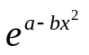 |  | 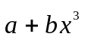 |  | 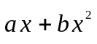 |  | 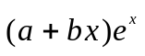 |  | 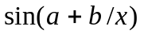
-1.5 | 0.54881 | 0 | -1.8 | 0.5 | 1.275 | -1.25 | -1.84796 | 1.5 | 0.99458
-1.2 | 1.04917 | 0.2 | -1.788 | 0.6 | 1.584 | -1 | -1.94976 | 2.5 | 0.86240
-0.9 | 1.73672 | 0.4 | -1.704 | 0.7 | 1.911 | -0.75 | -1.96032 | 3.5 | 0.75598
-0.6 | 2.4893 | 0.6 | -1.476 | 0.8 | 2.256 | -0.5 | -1.81959 | 4.5 | 0.68569
-0.3 | 3.08947 | 0.8 | -1.032 | 0.9 | 2.619 | -0.25 | -1.44078 | 5.5 | 0.63724
0 | 3.32012 | 1.0 | -0.3 | 1.0 | 3 | 0 | -0.70000 | 6.5 | 0.60212
0.3 | 3.08947 | 1.2 | 0.792 | 1.1 | 3.399 | 0.25 | 0.57781 | 7.5 | 0.57560
0.6 | 2.4893 | 1.4 | 2.316 | 1.2 | 3.816 | 0.5 | 2.63795 | 8.5 | 0.55489
0.9 | 1.73672 | 1.6 | 4.344 | 1.3 | 4.251 | 0.75 | 5.82175 | 9.5 | 0.53830
1.2 | 1.04917 | 1.8 | 6.948 | 1.4 | 4.704 | 1 | 10.60130 | 10.5 | 0.52472
1.5 | 0.54881 | 2.0 | 10.20 | 1.5 | 5.175 | 1.25 | 17.62623 | 11.5 | 0.51339
продолжение таблицы к задаче 6.2
6.2.6 |  | 6.2.7 |  |  | 6.2.8 |  |  |  | 6.2.9 |  | 6.2.10
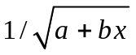 |  | 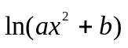 |  |  | 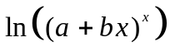 |  |  |  | 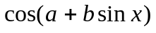 |  | 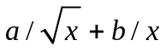
-0.2 | 0.39528 | -1.0 | 1.22378 |  | -0.5 |  | -0.86583 |  | 0 | 1 | 0.2 |  | -10.739
0 | 0.41523 | -0.8 | 0.95858 |  | -0.3 |  | -0.53703 |  | 0.1 | 0.93957 | 0.3 |  | -6.22126
0.2 | 0.43853 | -0.6 | 0.68914 |  | -0.1 |  | -0.18453 |  | 0.2 | 0.76783 | 0.4 |  | -4.07281
0.4 | 0.46625 | -0.4 | 0.43954 |  | 0.1 |  | 0.18976 |  | 0.3 | 0.51111 | 0.5 |  | -2.84020
0.6 | 0.50000 | -0.2 | 0.25309 |  | 0.3 |  | 0.58420 |  | 0.4 | 0.20634 | 0.6 |  | -2.05188
0.8 | 0.54233 | 0 | 0.18232 |  | 0.5 |  | 0.99735 |  | 0.5 | -0.10699 | 0.7 |  | -1.51050
1 | 0.59761 | 0.2 | 0.25309 |  | 0.7 |  | 1.42794 |  | 0.6 | -0.39443 | 0.8 |  | -1.11950
1.2 | 0.67420 | 0.4 | 0.43954 |  | 0.9 |  | 1.87487 |  | 0.7 | -0.63187 | 0.9 |  | -0.82632
1.4 | 0.79051 | 0.6 | 0.68914 |  | 1.1 |  | 2.33712 |  | 0.8 | -0.80753 | 1 |  | -0.60000
1.6 | 1.00000 | 0.8 | 0.95858 |  | 1.3 |  | 2.81381 |  | 0.9 | -0.92108 | 1.1 |  | -0.42121
1.8 | 1.58114 | 1.0 | 1.22378 |  | 1.5 |  | 3.30415 |  | 1 | -0.98077 | 1.2 |  | -0.27729
6.2.11 |  | 6.2.12 |  |  | 6.2.13 |  |  |  | 6.2.14 |  | 6.2.15
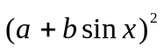 |  | 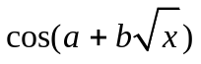 |  |  | 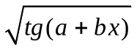 |  |  |  | 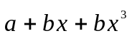 |  | 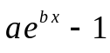
-0.5 | 25.51076 | 0.8 | -0.97931 |  | 0.1 |  | 1.08873 |  | -2 | 7 | -0.2 | 0.84579
-0.4 | 22.90612 | 1 | -0.85689 |  | 0.2 |  | 1.17014 |  | -1.5 | 4.4375 | 0 | 1.30000
-0.3 | 18.55157 | 1.2 | -0.66222 |  | 0.3 |  | 1.26183 |  | -1 | 3 | 0.2 | 1.86598
-0.2 | 14.54060 | 1.4 | -0.42857 |  | 0.4 |  | 1.36792 |  | -0.5 | 2.3125 | 0.4 | 2.57123
-0.1 | 10.95048 | 1.6 | -0.18049 |  | 0.5 |  | 1.49482 |  | 0 | 2 | 0.6 | 3.45002
0 | 7.84000 | 1.8 | 0.06400 |  | 0.6 |  | 1.65310 |  | 0.5 | 1.6875 | 0.8 | 4.54507
0.1 | 5.24799 | 2 | 0.29196 |  | 0.7 |  | 1.86204 |  | 1 | 1 | 1 | 5.90958
0.2 | 3.19261 | 2.2 | 0.49442 |  | 0.8 |  | 2.16181 |  | 1.5 | -0.4375 | 1.2 | 7.60987
0.3 | 1.67145 | 2.4 | 0.66554 |  | 0.9 |  | 2.65621 |  | 2 | -3 | 1.4 | 9.72856
0.4 | 0.66254 | 2.6 | 0.80200 |  | 1.0 |  | 3.75519 |  | 2.5 | -7.0625 | 1.6 | 12.36861
0.5 | 0.12598 | 2.8 | 0.90245 |  | 1.1 |  | 35.43678 |  | 3 | -13 | 1.8 | 15.65831
6.2.16 |  | 6.2.17 |  |  | 6.2.18 |  |  |  | 6.2.19 |  | 6.2.20
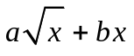 |  | 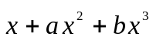 |  |  | 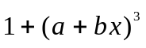 |  |  |  | 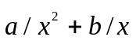 |  | 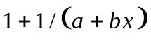
0.1 | 1.20491 | 1 | -0.5 |  | -1 | -49.653 |  |  | 1 | 3.6 | -0.5 | 1.22727
0.4 | 2.28982 | 1.4 | -0.5208 |  | -0.8 | -33.01222 |  |  | 1.2 | 2.23611 | 0 | 1.25
0.7 | 2.92664 | 1.8 | 0.3096 |  | -0.6 | -20.48495 |  |  | 1.4 | 1.44898 | 0.5 | 1.27778
1 | 3.4 | 2.2 | 2.4904 |  | -0.4 | -11.48717 |  |  | 1.6 | 0.96094 | 1 | 1.3125
1.3 | 3.7807 | 2.6 | 6.5208 |  | -0.2 | -5.43486 |  |  | 1.8 | 0.64198 | 1.5 | 1.35714
1.6 | 4.09964 | 3 | 12.900 |  | 0 | -1.744 |  |  | 2 | 0.425 | 2 | 1.41667
1.9 | 4.37362 | 3.4 | 22.1272 |  | 0.2 | 0.16942 |  |  | 2.2 | 0.27273 | 2.5 | 1.5
2.2 | 4.61296 | 3.8 | 34.7016 |  | 0.4 | 0.88941 |  |  | 2.4 | 0.16319 | 3 | 1.625
2.5 | 4.82456 | 4.2 | 51.1224 |  | 0.6 | 0.99999 |  |  | 2.6 | 0.08284 | 3.5 | 1.83333
2.8 | 5.01328 | 4.6 | 71.8888 |  | 0.8 | 1.08518 |  |  | 2.8 | 0.02296 | 4 | 2.25
3.1 | 5.18273 | 5 | 97.500 |  | 1 | 1.729 |  |  | 3 | -0.02222 | 4.5 | 3.5
6.2.21 |  | 6.2.22 |  |  | 6.2.23 |  |  |  | 6.2.24 |  | 6.2.25
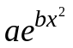 |  | 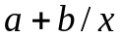 |  |  | 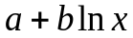 |  |  |  | 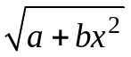 |  | 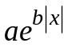
-2.5 | 0.0876 | 0.1 |  | 5.53 | 0.1 |  |  | 0.479 | -2.0 | 1.649 | -1.5 |  |  | 0.0829
-2 | 0.29523 | 0.3 |  | 2.7967 | 0.2 |  |  | 0.7562 | -1.6 | 1.942 | -1.2 |  |  | 0.2192
-1.5 | 0.75958 | 0.5 |  | 2.25 | 0.3 |  |  | 0.9184 | -1.2 | 2.142 | -0.9 |  |  | 0.5794
-1 | 1.49184 | 0.7 |  | 2.0157 | 0.4 |  |  | 1.0335 | -0.8 | 2.274 | -0.6 |  |  | 1.5315
-0.5 | 2.23671 | 0.9 |  | 1.8856 | 0.5 |  |  | 1.1227 | -0.4 | 2.35 | -0.3 |  |  | 4.0481
0 | 2.56000 | 1.1 |  | 1.8027 | 0.6 |  |  | 1.1957 | 0 | 2.375 | 0 |  |  | 10.7
0.5 | 2.23671 | 1.3 |  | 1.7454 | 0.7 |  |  | 1.2573 | 0.4 | 2.35 | 0.3 |  |  | 4.0481
1 | 1.49184 | 1.5 |  | 1.7033 | 0.8 |  |  | 1.3107 | 0.8 | 2.274 | 0.6 |  |  | 1.5315
1.5 | 0.75958 | 1.7 |  | 1.6712 | 0.9 |  |  | 1.3579 | 1.2 | 2.142 | 0.9 |  |  | 0.5794
2 | 0.29523 | 1.9 |  | 1.6458 | 1.0 |  |  | 1.4 | 1.6 | 1.942 | 1.2 |  |  | 0.2192
2.5 | 0.0876 | 2.1 |  | 1.6252 | 1.1 |  |  | 1.4381 | 2.0 | 1.649 | 1.5 |  |  | 0.0829
6.2.26 |  | 6.2.27 |  |  | 6.2.28 |  |  |  | 6.2.29 |  | 6.2.30
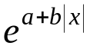 |  | 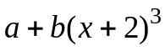 |  |  | 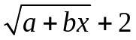 |  |  |  | 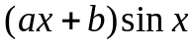 |  | 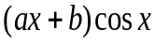
-2 | 8.16617 | -4 |  | -6.47 | 1 |  |  | 4.0199 | 0.5 | 1.7499 | -1.0 |  |  |  | 0.756
-1.6 | 5.92986 | -3.2 |  | -3.2086 | 1.7 |  |  | 3.9404 | 0.75 | 2.5732 | -0.8 |  |  |  | 1.0033
-1.2 | 4.30596 | -2.4 |  | -2.3433 | 2.4 |  |  | 3.8574 | 1 | 3.2817 | -0.6 |  |  |  | 1.2215
-0.8 | 3.12677 | -1.6 |  | -2.2767 | 3.1 |  |  | 3.7706 | 1.25 | 3.8197 | -0.4 |  |  |  | 1.4
-0.4 | 2.27050 | -0.8 |  | -1.4114 | 3.8 |  |  | 3.6793 | 1.5 | 4.1396 | -0.2 |  |  |  | 1.5289
0 | 1.64872 | 0 |  | 1.85 | 4.5 |  |  | 3.5827 | 1.75 | 4.2065 | 0 |  |  |  | 1.6
0.4 | 2.27050 | 0.8 |  | 9.105 | 5.2 |  |  | 3.4799 | 2.0 | 3.5208 | 0.2 |  |  |  | 1.6073
0.8 | 3.12677 | 1.6 |  | 21.951 | 5.9 |  |  | 3.3693 | 2.25 | 2.7829 | 0.4 |  |  |  | 1.5474
1.2 | 4.30596 | 2.4 |  | 41.986 | 6.6 |  |  | 3.249 | 2.5 | 1.8224 | 0.6 |  |  |  | 1.4196
1.6 | 5.92986 | 3.2 |  | 70.806 | 7.3 |  |  | 3.1158 | 2.75 | 0.6915 | 0.8 |  |  |  | 1.2262
2 | 8.16617 | 4 |  | 110.01 | 8 |  |  | 2.9644 | 3 | 0.6915 | 1.0 |  |  |  | 0.9725

Таблица к задаче 6.3
N | 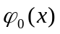 |  | 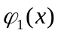 |  | 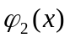 |  |  | 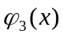
N | таблица значений
6.3.1 |  |  |  |  | 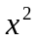 |  |  | 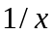
6.3.1 | x | 1.5 | 2 | 2.4 | 3 |  | 3.8 | 4.3 | 4.8 | 5.2
6.3.1 | y | 4.0 | 3.3 | 2.6 | 1.4 |  | -0.7 | -2.3 | -4.2 | -6.0
6.3.2 |  |  | 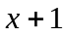 |  | 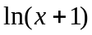 |  |  | 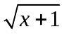
6.3.2 | x | 1.8 | 2 | 2.5 | 3.2 |  | 3.8 | 4.0 | 4.5 | 5.1
6.3.2 | y | -0.07 | -0.05 | 0 | 0.15 |  | 0.32 | 0.38 | 0.55 | 0.77
6.3.3 | 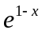 |  | 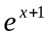 |  | 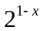 |  |  | 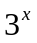
6.3.3 | x | -0.8 | -0.6 | -0.5 | -0.2 |  | 0 | 0.2 | 0.7
6.3.3 | y | 5.21 | 4.89 | 4.82 | 4.95 |  | 5.33 | 5.97 | 8.62
6.3.4 |  |  | 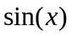 |  | 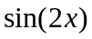 |  |  | 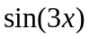
6.3.4 | x | -0.8 | -0.6 | -0.5 | -0.2 |  | 0 | 0.2 | 0.7 | 1.1 | 1.5
6.3.4 | y | 1.96 | 2.34 | 2.36 | 1.76 |  | 1 | 0.25 | -0.2 | 1.24 | 2.83
6.3.5 |  |  | 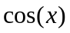 |  | 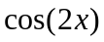 |  |  | 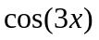
6.3.5 | x | 0 | 0.4 | 0.9 | 1.2 |  | 1.3 | 1.5 | 1.7 | 2.1
6.3.5 | y | 0 | 0.86 | 2.75 | 3 |  | 2.85 | 2.27 | 1.46 | 0
6.3.6
6.3.6 | x | 0 | 0.1 | 0.2 | 0.3 | 1 |  | 1.1 | 1.2 | 1.3 | 1.8 | 2.0
6.3.6 | y | -2.00 | -1.67 | -1.31 | -0.92 | 1.63 |  | 1.84 | 1.98 | 2.07 | 1.66 | 1.22
6.3.7 | 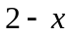 |  | 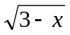 |  | 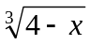
6.3.7 | x | 0.5 | 0.7 | 0.8 | 1.1 |  | 1.5 | 1.7 | 2.2 | 2.3 | 2.8 | 3.0
6.3.7 | y | 2.36 | 2.1 | 1.96 | 1.52 |  | 0.91 | 0.6 | -0.27 | -0.42 | -1.5 | -2.5
6.3.8 |  |  |  |  | 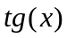
6.3.8 | x | 0 | 0.2 | 0.4 | 0.6 |  | 0.8 | 1 | 1.2 | 1.3 | 1.4
6.3.8 | y | 1 | 0.97 | 0.85 | 0.58 |  | 0.07 | -0.9 | -3 | -5 | -9.5
6.3.9 |  |  |  |  | 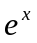
6.3.9 | x | 0 | 0.2 | 0.4 | 0.6 |  | 0.8 | 1 | 1.2 | 1.4
6.3.9 | y | 0 | 1 | 2.15 | 3.33 |  | 4.5 | 5.86 | 7.22 | 8.66
6.3.10 |  |  | 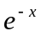
6.3.10 | x | 0.1 | 0.2 | 0.3 | 0.4 |  | 0.5 | 0.6 | 0.7 | 0.8 | 0.9 | 1.0
6.3.10 | y | 9.5 | 5 | 3.8 | 3.5 |  | 3.44 | 3.6 | 3.85 | 4.18 | 4.56 | 5
продолжение таблицы к задаче 6.3
6.3.11 |  |  |  |  | 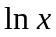
6.3.11 | x | 1.5 | 2 | 2.4 | 3 |  | 3.8 | 4.3 | 4.8 | 5.2 | 5.5 | 6
6.3.11 | y | -0.9 | -2.1 | -2.8 | -3.7 |  | -4.7 | -5.1 | -5.6 | -5.9 | -6.1 | -6.5
6.3.12 |  |  | 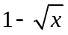 |  | 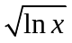 |  |  | 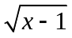
6.3.12 | x | 1.5 | 2 | 2.5 | 3 |  | 3.5 | 4 | 4.5 | 5 | 5.5 | 6
6.3.12 | y | -0.53 | -0.33 | -0.14 | 0.05 |  | 0.23 | 0.40 | 0.56 | 0.72 | 0.88 | 1.0
6.3.13 | 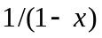 |  |  |  | 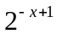
6.3.13 | x | -0.5 | -0.3 | -0.1 | 0 |  | 0.2 | 0.4 | 0.5
6.3.13 | y | 10.57 | 9.8 | 9.2 | 9 |  | 8.67 | 8.58 | 8.70
6.3.14 | 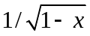 |  |  |  | 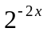
6.3.14 | x | -1 | -0.7 | -0.3 | 0.2 |  | 0.4 | 0.6 | 0.8
6.3.14 | y | 24.8 | 17.5 | 12 | 9.4 |  | 9.4 | 10.1 | 12.5
6.3.15 | 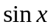 |  |  |  | 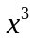
6.3.15 | x | -1 | -0.7 | -0.3 | 0.2 |  | 0.4 | 0.6 | 0.8
6.3.15 | y | -11.4 | -6.04 | -1.94 | 1.24 |  | 2.74 | 4.76 | 7.51
6.3.16 |  |  |  |  | 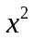 |  |  | 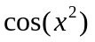
6.3.16 | x | -1 | -0.5 | 0 | 0.5 | 1 |  | 1.5 | 2 | 2.5
6.3.16 | y | 14.16 | 11.20 | 10 | 11.20 | 14.16 |  | 18.39 | 27.86 | 43.90
6.3.17 |  |  |  |  | 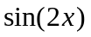 |  |  | 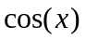
6.3.17 | x | -1 | -0.5 | 0 | 0.5 |  | 1 | 1.5 | 2 | 2.5
6.3.17 | y | 0.942 | -2.503 | 2 | 9.513 |  | 15.2 | 18.7 | 24.5 | 36
6.3.18 |  |  | 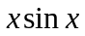 |  |  |  |  | 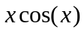
6.3.18 | x | 0 | 0.2 | 0.4 | 0.6 |  | 0.8 | 1 | 1.2 | 1.4 | 1.6 | 1.8
6.3.18 | y | 6.01 | 8.01 | 9.9 | 11.5 |  | 12.6 | 13.2 | 13 | 12.1 | 10.4 | 8.1
6.3.19 |  |  | 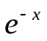 |  | 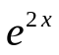
6.3.19 | x | -1 | -0.5 | -0.3 | -0.1 |  | 0 | 0.2 | 0.4 | 0.5 | 0.7 | 0.9 | 1
6.3.19 | y | 14.6 | 12.52 | 12.71 | 11.7 |  | 11.6 | 11.5 | 11.7 | 11.8 | 12.4 | 13.4 | 14.2
6.3.2 0 | 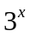 |  | 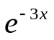
6.3.2 0 | x | -1 | -0.5 | -0.3 | -0.1 |  | 0 | 0.2 | 0.4 | 0.5 | 0.7 | 0.9 | 1
6.3.2 0 | y | 22.4 | 8.7 | 7.9 | 8.4 |  | 9 | 11 | 14.1 | 16.1 | 21.2 | 28.3 | 32.8
6.3.21 |  |  |  |  | 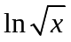
6.3.21 | x | 1.5 | 2 | 2.4 | 3 |  | 3.8 | 4.3 | 4.8 | 5.2 | 5.5 | 6
6.3.21 | y | -0.9 | -2.1 | -2.8 | -3.7 |  | -4.7 | -5.1 | -5.6 | -5.9 | -6.1 | -6.5
6.3.22 |  |  | 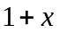
6.3.22 | x | 1.5 | 2 | 2.5 | 3 |  | 3.5 | 4 | 4.5 | 5 | 5.5 | 6
6.3.22 | y | -0.53 | -0.33 | -0.14 | 0.05 |  | 0.23 | 0.40 | 0.56 | 0.72 | 0.88 | 1.0
6.3.23 | 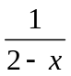 |  | 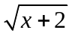 |  | 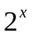
6.3.23 | x | -0.5 | -0.3 | -0.1 | 0 |  | 0.2 | 0.4 | 0.5
6.3.23 | y | 10.57 | 9.8 | 9.2 | 9 |  | 8.67 | 8.58 | 8.70
6.3.24 | 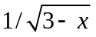 |  | 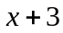 |  | 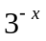
6.3.24 | x | -1 | -0.7 | -0.3 | 0.2 |  | 0.4 | 0.6 | 0.8
6.3.24 | y | 24.8 | 17.5 | 12 | 9.4 |  | 9.4 | 10.1 | 12.5

6.3.25 |  |  | +2
6.3.25 | x | -1 | -0.7 | -0.3 | 0.2 |  | 0.4 | 0.6 | 0.8
6.3.25 | y | -11.4 | -6.04 | -1.94 | 1.24 |  | 2.74 | 4.76 | 7.51
6.3.26 |  |  |  |  | 1+
6.3.26 | x | -1 | -0.5 | 0 | 0.5 | 1 |  | 1.5 | 2 | 2.5
6.3.26 | y | 14.16 | 11.20 | 10 | 11.20 | 14.16 |  | 18.39 | 27.86 | 43.90
6.3.27 |  |  |  |  |  |  |  | 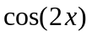
6.3.27 | x | -1 | -0.5 | 0 | 0.5 |  | 1 | 1.5 | 2 | 2.5
6.3.27 | y | 0.942 | -2.503 | 2 | 9.513 |  | 15.2 | 18.7 | 24.5 | 36
6.3.28 |  |  | 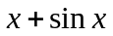 |  |  |  |  | 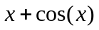
6.3.28 | x | 0 | 0.2 | 0.4 | 0.6 |  | 0.8 | 1 | 1.2 | 1.4 | 1.6 | 1.8
6.3.28 | y | 6.01 | 8.01 | 9.9 | 11.5 |  | 12.6 | 13.2 | 13 | 12.1 | 10.4 | 8.1
6.3.29 |  |  | 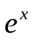 |  | 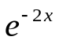
6.3.29 | x | -1 | -0.5 | -0.3 | -0.1 |  | 0 | 0.2 | 0.4 | 0.5 | 0.7 | 0.9 | 1
6.3.29 | y | 14.6 | 12.52 | 12.71 | 11.7 |  | 11.6 | 11.5 | 11.7 | 11.8 | 12.4 | 13.4 | 14.2
6.3.30 |  |  |  |  | 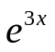
6.3.30 | x | -1 | -0.5 | -0.3 | -0.1 |  | 0 | 0.2 | 0.4 | 0.5 | 0.7 | 0.9 | 1
6.3.30 | y | 22.4 | 8.7 | 7.9 | 8.4 |  | 9 | 11 | 14.1 | 16.1 | 21.2 | 28.3 | 32.8

Методы решения СЛАУ ( Приложение к таблице к задаче 6.3)

Итерационными методами решать систему с точностью 10⁻⁸
N | Метод | N | Метод
6.3.1 | Гаусса (схема единственного деления) | 6.3.16 | LU – разложения
6.3.2 | Холецкого | 6.3.17 | Якоби
6.3.3 | LU – разложения | 6.3.18 | LU – разложения
6.3.4 | Якоби | 6.3.19 | Гаусса (схема частичного выбора)
6.3.5 | Зейделя | 6.3.20 | Гаусса (схема полного выбора)
6.3.6 | Холецкого | 6.3.21 | Зейделя
6.3.7 | Релаксации | 6.3.22 | LU – разложения
6.3.8 | Зейделя | 6.3.23 | Якоби
6.3.9 | Гаусса (схема полного выбора) | 6.3.24 | Зейделя
6.3.10 | Гаусса (схема частичного выбора) | 6.3.25 | Релаксации
6.3.11 | Холецкого | 6.3.26 | Холецкого
6.3.12 | Якоби | 6.3.27 | Гаусса (схема частичного выбора)
6.3.13 | Релаксации | 6.3.28 | Гаусса (схема полного выбора)
6.3.14 | Гаусса (схема единственного деления) | 6.3.29 | Гаусса (схема единственного деления)
6.3.15 | Зейделя | 6.3.30 | Релаксации

ПРИЛОЖЕНИЕ 6.B.

Фрагмент решения задачи 6.1.0
Векторы исходных данных:

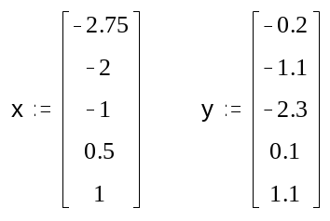

Функция mnk, строящая многочлен степени m по методу наименьших квадратов,
возвращает вектор a коэффициентов многочлена:

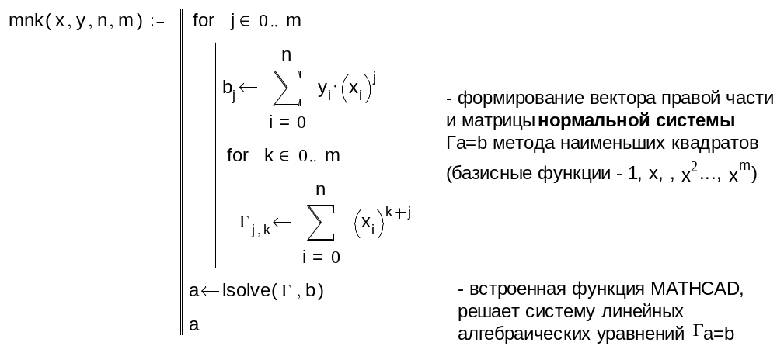

Входные параметры:
x, y - векторы исходных данных; n+1 - размерность x,y.
Вычисление коэффициентов многочленов степени 0,1,2,3 по методу наименьших квадратов:
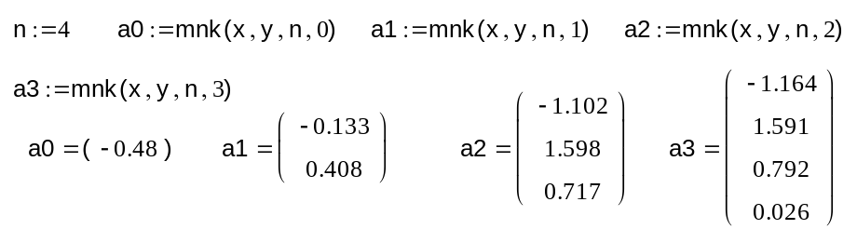

Функция P возвращает значение многочлена степени m в точке t; многочлен задается с помощью вектора коэффициентов a:
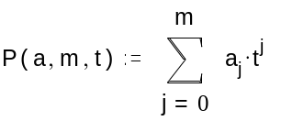
Функция 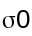 возвращает значение среднеквадратичного уклонения многочлена P(a,m,t):
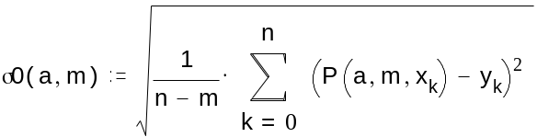

Вычисление значений 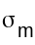, m=0,1,2,3:

Гистограмма
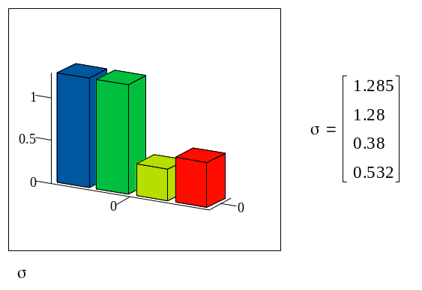
Вывод: оптимальная степень m*=2; многочлен наилучшего среднеквадратичного приближения: P2(x)=-1.102+1.598x+0.717
Графики многочленов степени 0,1,2 и точечный график исходной функции: 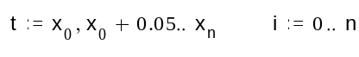
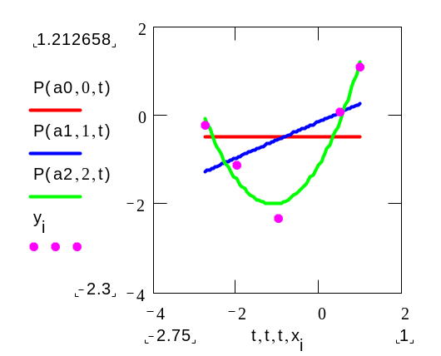

ЛИТЕРАТУРА
1. Амосов А.А., Дубинский Ю.А., Копченова Н.В. Вычислительные методы для инженеров. М.: Высшая школа, 1994.

